A Project Report On

Intelligent Infant Health Predictor with Personalized AI Guidance

Submitted
in partial fulfillment for the award of the degree of
Bachelor of Technology
In

COMPUTER SCIENCE AND ENGINEERING (ARTIFICIAL INTELLIGENCE AND DATA SCIENCE)

by

22F61A4788 | - K LALITH
22F61A4793 | - P MAHITHA PRANATHI
22F61A4790 | - P MADHU
22F61A47A0 | - K MANOJKUMAR

Under the esteemed guidance of
B. SRINIVASULU, M.Tech.

Assistant Professor, Department of CSE(AIMD)
Department of Computer Science and Engineering
(Artificial Intelligence and Machine Learning)

SIDDHARTH INSTITUTE OF ENGINEERING & TECHNOLOGY (AUTONOMOUS)
(Approved by AICTE & Affiliated to JNTUA, Ananthapuram) (Accredited by NBA for Civil, EEE, ECE, MECH & CSE) (Accredited by NAAC with ‘A+’ Grade)
Siddharth Nagar, Narayanavanam Road, Puttur-517583, A.P 2026

SIDDHARTH INSTITUTE OF ENGINEERING & TECHNOLOGY (AUTONOMOUS)
(Approved by AICTE & Affiliated to JNTUA, Ananthapuram) (Accredited by NBA for Civil, EEE, ECE, MECH & CSE) (Accredited by NAAC with ‘A+’ Grade)
Siddharth Nagar, Narayanavanam Road, Puttur-517583, A.P


DEPARTMENT OF COMPUTER SCIENCE AND ENGINEERING (ARTIFICIAL INTELLIGENCE AND DATA SCIENCE)
BONAFIDE CERTIFICATE
Certified that this project report titled “INTELLIGENT INFANT HEALTH PREDICTOR WITH PERSONALIZED AI GUIDANCE” is a bonafied work of

22F61A4788 | - | K LALITH
22F61A4793 | - | P MAHITHA PRANATHI
22F61A4790 | - | P MADHU
22F61A47A0 | - | K MANOJKUMAR

in IV B.Tech II Semester of Computer Science and Engineering (Artificial Intelligence and Data Science). The results embodied in this project report have not been submitted to any other university for award of any degree.

Supervisor Head of the Department
B. Srinivasulu, M.Tech., Dr. E. Murali M.Tech., Ph.D.,
Assistant Professor, HOD and Professor,
Department of CSE(AIMD), Department of CSE(AIMD),
SIETK. SIETK.

Submitted for the main Project viva-voce examination held on

INTERNAL EXAMINAR EXTERNAL EXAMINAR

ACKNOWLEDGEMENT
We take this opportunity to acknowledge all the people who helping us to do our project a successful one.
We greatly convey our sincere thanks to our beloved chairman Dr. K. Ashok Raju, M.A, Ph.D., and Vice chairperson Dr. K. Indiraveni, M.Tech., Ph.D., for providing us the facilities and time for accomplishing the Project work.

We wish to express our profound gratitude to one of our all-time well-wisher and Principal of our college Dr. P. Ramesh Kumar, M.E., Ph.D., for his constant encouragement for completing the Project work successfully.
We wish to thank our Head of the Department, Dr. E. Murali, M.Tech., Ph.D., for his guidance in accomplishing the Project work.
We wish to convey our heartfelt thanks to Dr. N. Babu, M.E., Ph.D., Super- visor of this project and Dr. M. Karthikeyan, M.E., Ph.D., Project Coordinator, who supported and helped to make this Project work as successful one.
We extend our thanks to all the faculty members of the CSE Department and Lab technicians, who gave us the moral support for the completion of the Project work.
We also extend our thanks to our parents and our friends for the encouragement in proceeding the Project work in right way and for the completion of the Project work in successful way.

LIST OF CONTENTS

CHAPTER NO | NAME OF THE CONTENTS | PAGE NO
 | BONAFIDE CERTIFICATE | ⅰ
 | ACKNOWLEDGEMENT | ii
 | LIST OF CONTENTS | iii-ⅴ
 | LIST OF FIGURES | ⅵ
 | LIST OF TABLES | ⅶ
 | LIST OF ABBREVIATIONS | vii
 | ABSTRACT | ⅷ
CHAPTER 1 | INTRODUCTION | 1-2
 | 1.1 INTRODUCTION | 1
 | 1.2 PROBLEM STATEMENT | 2
CHAPTER 2 | LITERATURE REVIEW | 3-7
 | 2.1 TRADITIONAL INFANT HEALTH ASSESSMENT METHODS | 3
 | 2.2 INFANT MORTALITY STUDIES AND EPIDEMIOLOGICAL MODELS | 3
 | 2.3 ROLE OF MATERNAL AND SOCIOECONOMIC FACTORS | 4
 | 2.4 HEALTHCARE DATA MINING AND MACHINE LEARNING | 4
 | 2.5 SUPERVISED MACHINE LEARNING FOR MORTALITY PREDICTION | 4
 | 2.6 ENSEMBLE LEARNING TECHNIQUES IN HEALTHCARE | 4
 | 2.7 CATBOOST IN MEDICAL AND HEALTHCARE PREDICTION | 5
 | 2.8 DATA IMBALANCE IN HEALTHCARE DATASETS | 5
 | 2.9 FEATURE ENGINEERING AND SELECTION | 5
 | 2.10 PREDICTIVE ANALYTICS FOR EARLY INTERVENTION  2.11 PERSONALIZATION IN HEALTHCARE AI SYSTEMS  2.12 EXPLAINABILITY AND TRUST IN MEDICAL AI  2.13 PERFORMANCE METRICS IN HEALTHCARE PREDICTION MODELS  2.14 DATA PRIVACY AND ETHICAL CONSIDERATIONS  2.15 INTEGRATION WITH PUBLIC HEALTH SYSTEMS  2.16 LIMITATIONS OF EXISTING INFANT MORTALITY PREDICTION SYSTEMS  2.17 NEED FOR AI-DRIVEN INFANT HEALTH PREDICTION SYSTEMS  2.18 INTEGRATION OF ML AND DECISION SUPPORT SYSTEMS  2.19 RESEARCH GAP AND MOTIVATION  2.20 SUMMARY AND RESEARCH DIRECTION | 5  6  6  6  6  6  7  7  7  7  7
CHAPTER 3 | SYSTEM ANALYSIS | 8-18
 | 3.1 EXISTING SYSTEM | 8
 | 3.2 PROPOSED SYSTEM | 10
 | 3.3 PROJECT ALGORITHM | 13
 | 3.4 INTELLIGENT INFANT HEALTH PREDICTION SYSTEM – BLOCK DIAGRAM | 16
 | 3.5 SYSTEM SPECIFICATIONS | 17
 | 3.6 FEASIBILITY STUDY | 18

CHAPTER 4 | SYSTEM DESIGN | 19-27
 | 4.1 SYSTEM ARCHITECTURE | 19
 | 4.2 INPUT DESIGN | 21
 | 4.3 OUTPUT DESIGN | 21
 | 4.4 UML DIAGRAMS | 22
 | 4.5 MODULES | 26
CHAPTER 5 | SYSTEM IMPLEMENTATION | 28-40
 | 5.1 SOFTWARE INSTALLATION | 28
 | 5.2 INTRODUCTION TO PYTHON | 30
 | 5.3 WEB FRAMEWORK | 38
CHAPTER 6 | SYSTEM TESTING | 41-47
 | 6.1 SYSTEM TESTING | 41
 | 6.2 UNIT TESTING | 43
 | 6.3 INTEGRATION TESTING | 45
 | 6.4 FUNCTIONAL TESTING | 45
 | 6.5 ACCEPTANCE TESTING | 45
 | 6.6 TEST CASES | 46
CHAPTER 7 | EXPERIMENTAL ANALYSIS | 48-53
 | 7.1 EXECUTION PROCEDURE | 48
 | 7.2 OUTPUT SCREENSHOT AND DESCRIPTION | 50
CHAPTER 8 | CONCLUSION AND FUTURE SCOPE | 54-55
 | 8.1 CONCLUSION | 54
 | 8.2 FUTURE SCOPE | 55
 | CERTIFICATE | 56
 | PUBLISHED PAPER | pg.1 – pg.12
 | REFERENCES | pg.13 –  pg.14

LIST OF FIGURES

FIGURE NO | NAME OF THE FIGURE | PAGE NO
4.1 | System Architecture | 20
4.2 | Use case Diagram | 23
4.3 | Class Diagram | 24
4.4 | Sequence Diagram | 25
4.5 | Deployment Diagram | 26
4.6 | Activity Diagram | 27
5.1 | Installation of python | 30
5.2 | Installation of vs code | 31
7.1 | Program file opened in vs code | 117
7.2 | Running program file “app.py” in the terminal of vs code | 117
7.3 | Executed and hosting a local host for web application | 118
7.4 | Dashboard Overview | 118
7.5 | Healthcare Recommendations / Generated Survival Plan | 119
7.6 | Risk Predictor and Explain of prediction | 120

LIST OF TABLES

TABLE NO | NAME OF THE TABLE | PAGE NO
6.1 | Test Cases | 48-49

LIST OF ABBREVIATIONS

AI | Artificial Intelligence
ML | Machine Learning
DL | Deep Learning
BMI | Body Mass Index
API | Application Programming Interface
GUI | Graphical User Interface
UML | Unified Modelling Language
DB | Database
CNN | Convolutional Neural Network
RNN | Recurrent Neural Network

ABSTRACT

Infant mortality continues to be one of the most pressing global public health challenges, particularly affecting children under the age of five in low- and middle-income regions. Timely identification of infants who are at a higher risk of mortality is crucial for enabling early medical intervention, targeted healthcare planning, and effective policy implementation to improve survival outcomes. In response to this challenge, this project presents an integrated Machine Learning and AI–driven predictive framework designed to assess infant mortality risk by analyzing a comprehensive set of maternal, infant, and socio-environmental health indicators. The key features considered in the system include birth weight, maternal age, immunization status, nutritional score, socioeconomic category, and the number of prenatal care visits, all of which play a significant role in determining infant health and survival. The proposed framework employs supervised machine learning classification techniques to model complex, non-linear relationships among these factors and accurately predict mortality risk. To address class imbalance commonly present in healthcare datasets, the Synthetic Minority Over-sampling Technique (SMOTE) was applied, ensuring fair and unbiased model training. Multiple classification models were trained, tested, and evaluated using standard performance metrics, and among them, the CatBoost Classifier demonstrated superior predictive accuracy, robustness, and generalization capability. Consequently, CatBoost was selected as the final predictive model for the system. The enhanced predictive capability of this AI-driven approach supports proactive healthcare decision-making, enabling healthcare professionals and policymakers to identify high-risk infants early and implement timely interventions, ultimately contributing to reduced infant mortality rates and improved child health outcomes.

Keywords: Infant Mortality Prediction, Artificial Intelligence in Healthcare, Machine Learning Classification, Personalized Health Guidance, CatBoost Classifier, Maternal and Infant Health Indicators, Predictive Analytics, Early Risk Detection, Child Health Management, Public Health Decision Support

CHAPTER 1 INTRODUCTION

INTRODUCTION
Infant mortality remains a significant indicator of a nation’s healthcare quality and socio-economic development, with under-five mortality rates still alarmingly high in many low- and middle-income regions. Despite advances in medical science, preventable factors such as inadequate prenatal care, poor nutrition, delayed immunization, and socio-economic disparities continue to place infants at elevated risk during their early stages of life. Traditional healthcare systems often rely on retrospective analysis and generalized guidelines, which limits their ability to identify high-risk infants early and deliver personalized interventions in a timely manner.
To address these challenges, the Intelligent Infant Health Predictor with Personalized AI Guidance introduces an advanced, data-driven framework that leverages Machine Learning and Artificial Intelligence to assess infant mortality risk proactively. By analyzing critical maternal, infant, and environmental health indicators—including birth weight, maternal age, immunization status, nutritional score, socioeconomic category, and prenatal care visits—the system learns complex patterns associated with infant health outcomes. Unlike conventional approaches, the proposed system not only predicts mortality risk but also supports personalized, AI-driven guidance to assist healthcare professionals and caregivers in making informed decisions.
The framework utilizes supervised machine learning models trained on balanced healthcare datasets to ensure reliable and unbiased predictions. Through rigorous evaluation, the CatBoost Classifier was identified as the most effective model, offering high accuracy, robustness, and interpretability. By integrating predictive analytics with personalized AI insights, the system enables early identification of vulnerable infants, supports targeted medical interventions, and enhances strategic healthcare planning. Ultimately, this intelligent predictor aims to strengthen preventive care, reduce infant mortality rates, and improve overall child health outcomes through timely, personalized, and evidence-based decision support.

PROBLEM STATEMENT
Infant mortality remains a major public health concern, particularly in low- and middle-income regions, where preventable and manageable factors continue to contribute to high death rates among infants and children under five years of age. Despite the availability of healthcare data related to maternal health, infant conditions, and socio-economic factors, existing healthcare systems often lack intelligent mechanisms to analyze this data effectively and predict mortality risk at an early stage. As a result, high-risk infants are frequently identified too late, reducing the chances of timely medical intervention and survival.
Conventional assessment methods rely heavily on manual evaluation, generalized risk scoring, and retrospective analysis, which are limited in handling large, complex, and imbalanced healthcare datasets. These approaches fail to capture non-linear relationships among critical indicators such as birth weight, maternal age, immunization status, nutrition levels, socioeconomic conditions, and prenatal care history. Moreover, the absence of personalized, data-driven guidance restricts healthcare providers from implementing targeted and proactive care strategies.
Therefore, there is a pressing need for an intelligent, AI-driven predictive system that can accurately assess infant mortality risk using multiple health indicators, handle data imbalance, and provide reliable predictions in real time. Such a system should support early risk identification, personalized healthcare guidance, and informed decision-making for clinicians and policymakers, ultimately contributing to reduced infant mortality rates and improved infant health outcomes.

CHAPTER 2 LITERATURE REVIEW
The literature review is a crucial phase in the development of the Intelligent Infant Health Predictor with Personalized AI Guidance, as it provides a comprehensive understanding of existing research, methodologies, technologies, datasets, and challenges related to infant mortality prediction, maternal and child health analytics, healthcare data mining, and the application of machine learning and artificial intelligence in public health decision support systems. Reviewing prior work helps identify effective predictive models, health risk assessment techniques, feature selection strategies, data balancing methods, and personalized recommendation approaches that can be leveraged to design an accurate, reliable, and clinically meaningful infant health prediction framework.
A systematic review of existing literature also highlights significant limitations of traditional infant health assessment and mortality prediction approaches, such as reliance on manual evaluation, static risk scoring, limited use of data-driven intelligence, poor handling of imbalanced datasets, and lack of personalized guidance. These insights form the foundation for designing an AI-driven system that integrates advanced machine learning models with interpretable and personalized health recommendations to support early intervention and improved infant survival outcomes.

2.1 TRADITIONAL INFANT HEALTH ASSESSMENT METHODS
Traditional infant health assessment methods rely on clinical judgment, basic statistical indicators, and retrospective analysis of maternal and child health records. Literature indicates that while these approaches are useful for general monitoring, they are often subjective, time-consuming, and limited in predictive accuracy. They fail to proactively identify high-risk infants at an early stage and do not scale well with large healthcare datasets. These approaches, although widely used, are often subjective and depend heavily on the experience of healthcare professionals. They are also time-consuming and limited in their ability to process large volumes of healthcare data efficiently. Furthermore, such methods focus more on post-event analysis rather than early prediction, which restricts their effectiveness in identifying high-risk infants at an early stage. With the increasing availability of digital health data, these conventional techniques are becoming inadequate for modern healthcare needs.

2.2 INFANT MORTALITY STUDIES AND EPIDEMIOLOGICAL MODELS
Epidemiological studies have played a crucial role in understanding infant mortality by analyzing population-level trends and identifying key risk factors. These studies commonly use statistical models such as regression analysis to examine relationships between variables like birth weight, maternal age, nutrition, and healthcare access. While these models provide valuable insights, they often struggle to capture complex, non-linear relationships among multiple influencing factors. Additionally, they are generally limited to aggregated data analysis and may not perform well in individual-level risk prediction, which is essential for personalized healthcare interventions.

2.3 ROLE OF MATERNAL AND SOCIOECONOMIC FACTORS
Infant mortality is deeply influenced by maternal health and socioeconomic conditions, making it a multidimensional problem rather than purely a medical issue. Factors such as maternal education, income level, access to healthcare facilities, and living conditions significantly impact infant survival rates. Poor maternal nutrition, lack of awareness, and inadequate prenatal care further increase the risk. Integrating these socio-environmental variables into predictive models enhances their accuracy and relevance, enabling a more holistic understanding of infant health outcomes and improving targeted intervention strategies.

2.4 HEALTHCARE DATA MINING AND MACHINE LEARNING
The emergence of digital healthcare records has enabled the application of data mining and machine learning techniques in medical research. These approaches allow the extraction of meaningful patterns and insights from large and complex datasets that are difficult to analyze using traditional methods. Machine learning algorithms can automatically learn relationships between variables and improve prediction performance over time. In the context of infant mortality, these techniques provide a powerful tool for identifying hidden risk factors and improving early diagnosis and intervention.

2.5 SUPERVISED MACHINE LEARNING FOR MORTALITY PREDICTION
Supervised machine learning algorithms have been widely used in mortality prediction tasks due to their ability to learn from labeled data. Models such as Logistic Regression, Decision Trees, Random Forests, Support Vector Machines, and Gradient Boosting are commonly applied in healthcare analytics. These models are trained using historical data and can predict outcomes based on input features. While they offer improved accuracy compared to traditional statistical models, their performance is highly dependent on data quality, feature selection, and class balance, which remain critical challenges in healthcare datasets.

2.6 ENSEMBLE LEARNING TECHNIQUES IN HEALTHCARE
Ensemble learning techniques combine multiple models to produce more accurate and robust predictions. Methods such as Random Forest, XGBoost, and Bagging improve performance by reducing variance and avoiding overfitting. In healthcare applications, ensemble models are particularly effective because they can handle diverse data types and capture complex relationships among features. Their ability to generalize well across different datasets makes them highly suitable for infant mortality prediction systems.

2.7 CATBOOST IN MEDICAL AND HEALTHCARE PREDICTION
Recent studies show that CatBoost Classifier performs exceptionally well on structured healthcare datasets, especially those with categorical features making it suitable for infant mortality risk prediction. CatBoost is a powerful gradient boosting algorithm that has gained attention in healthcare prediction tasks due to its ability to handle categorical data efficiently. Unlike traditional models, it requires minimal preprocessing and reduces the risk of overfitting. Recent studies indicate that CatBoost performs exceptionally well on structured healthcare datasets, making it an ideal choice for infant mortality risk prediction. Its robustness and high accuracy contribute to improved predictive performance in real-world applications.

2.8 DATA IMBALANCE IN HEALTHCARE DATASETS
A common challenge identified in literature is class imbalance, where mortality cases are significantly fewer than survival cases. This imbalance leads to biased models with poor sensitivity. Techniques such as SMOTE (Synthetic Minority Over-sampling Technique) are widely recommended to address this issue and improve minority class prediction. This imbalance can lead to biased models that favor the majority class and fail to accurately predict high-risk cases. Techniques such as SMOTE (Synthetic Minority Over-sampling Technique) are widely used to address this issue by generating synthetic samples for the minority class. Proper handling of imbalanced data is essential to improve model sensitivity and ensure reliable predictions.

2.9 FEATURE ENGINEERING AND SELECTION
Research highlights the importance of selecting relevant features such as birth weight, maternal age, prenatal care visits, immunization status, and nutrition indicators enhances model accuracy and interpretability in infant health prediction systems. Selecting relevant features such as birth weight, maternal age, prenatal care visits, and immunization status enhances model accuracy and interpretability. Additionally, techniques such as normalization, encoding, and transformation help in preparing data for effective model training. Proper feature selection reduces noise and ensures that the model focuses on the most influential factors affecting infant mortality.

2.10 PREDICTIVE ANALYTICS FOR EARLY INTERVENTION
Predictive analytics enables early identification of high-risk infants, allowing healthcare providers to implement preventive measures. Literature supports the use of AI-driven prediction systems for proactive healthcare planning rather than reactive treatment. Predictive analytics enables the early identification of infants who are at high risk of mortality, allowing healthcare providers to take preventive measures. By analyzing patterns in historical data, predictive models can forecast potential health outcomes and support proactive decision-making. This shift from reactive to preventive healthcare is crucial in reducing infant mortality rates and improving overall healthcare efficiency.

2.11 PERSONALIZATION IN HEALTHCARE AI SYSTEMS
Personalized healthcare systems aim to tailor predictions and recommendations based on individual patient profiles. In infant health prediction, personalization ensures that interventions are specific to each case rather than generalized. This approach improves treatment effectiveness and builds trust among healthcare providers and patients. Personalized AI systems are increasingly becoming essential in modern healthcare due to their ability to deliver targeted and efficient care.

2.12 EXPLAINABILITY AND TRUST IN MEDICAL AI
Explainability is a critical aspect of AI systems in healthcare, as decisions directly impact human lives. Models that provide clear explanations for their predictions are more likely to be trusted by healthcare professionals. Techniques such as SHAP and LIME help in understanding feature contributions and improving transparency. Ensuring explainability not only enhances trust but also supports ethical adoption of AI in medical applications.

2.13 PERFORMANCE METRICS IN HEALTHCARE PREDICTION MODELS

Evaluating the performance of prediction models is essential to ensure their reliability. Common metrics include accuracy, precision, recall, F1-score, and ROC-AUC. In healthcare applications, recall and sensitivity are particularly important because failing to identify high-risk cases can have severe consequences. Therefore, models must be optimized to minimize false negatives while maintaining overall accuracy.

2.14 DATA PRIVACY AND ETHICAL CONSIDERATIONS
Handling sensitive maternal and infant health data requires strict adherence to privacy and ethical guidelines and compliance with healthcare data protection regulations. Compliance with data protection regulations and anonymization techniques is necessary to ensure patient confidentiality. Ethical AI practices also require transparency, fairness, and accountability in model development and deployment.

2.15 INTEGRATION WITH PUBLIC HEALTH SYSTEMS
Research indicates that predictive models are most effective when integrated into existing healthcare workflows and public health systems, enabling real-time risk assessment and policy-level decision support. For predictive models to be effective, they must be integrated into existing healthcare systems and workflows. Integration enables real-time data analysis and supports decision-making at both clinical and policy levels. By embedding predictive systems into public health infrastructure, healthcare providers can improve resource allocation and enhance service delivery.

2.16 LIMITATIONS OF EXISTING INFANT MORTALITY PREDICTION SYSTEMS
Despite advancements, many existing systems suffer from limited generalization, lack of personalization, poor handling of imbalanced data, and absence of actionable guidance for healthcare providers. Many models also fail to provide actionable insights, limiting their practical usability. Addressing these challenges is essential for developing more effective and reliable prediction systems.

2.17 NEED FOR AI-DRIVEN INFANT HEALTH PREDICTION SYSTEMS
Literature strongly supports the adoption of AI-driven frameworks that combine predictive accuracy, interpretability, and personalized guidance to address infant mortality more effectively. There is a growing need for AI-driven systems that can combine predictive accuracy, interpretability, and personalization. Such systems can overcome the limitations of traditional approaches and provide comprehensive solutions for infant health prediction. The integration of advanced machine learning techniques with healthcare systems can significantly improve outcomes and reduce mortality rates.

2.18 INTEGRATION OF ML AND DECISION SUPPORT SYSTEMS
Combining machine learning predictions with decision support tools enables actionable insights for clinicians and policymakers, improving healthcare outcomes. These systems assist healthcare professionals by providing recommendations based on predicted risk levels. This integration enhances clinical decision-making and improves patient care.

2.19 RESEARCH GAP AND MOTIVATION
The literature reveals a gap in intelligent systems that integrate robust machine learning models, balanced data handling, personalized risk assessment, and AI-based guidance into a single, unified infant health prediction platform. Most current approaches focus on individual aspects rather than providing a complete solution. This gap motivates the development of an intelligent infant health prediction system that combines all these features into a single platform.

2.20 SUMMARY AND RESEARCH DIRECTION
Overall, existing research demonstrates strong potential for machine learning and AI in predicting infant mortality risk. However, challenges related to early prediction, data imbalance, personalization, interpretability, and clinical usability remain unresolved. These findings motivate the proposed Intelligent Infant Health Predictor with Personalized AI Guidance, which aims to deliver an accurate, interpretable, and proactive AI-driven framework to support early intervention, personalized healthcare planning, and improved infant survival outcomes.

CHAPTER 3 SYSTEM ANALYSIS
System analysis is a critical phase in the development of intelligent healthcare prediction systems that focuses on understanding existing infant health assessment practices, identifying their limitations, and defining the requirements for an improved, accurate, data-driven, and proactive solution. In the context of infant mortality and child health management, system analysis helps evaluate how traditional clinical assessments, statistical health indicators, and rule-based decision-making approaches operate and why they often fail to provide early risk prediction, personalized guidance, and scalable decision support. This analysis forms the foundation for designing the Intelligent Infant Health Predictor with Personalized AI Guidance, capable of early risk identification, predictive analytics, and personalized healthcare recommendations.
3.1 EXISTING SYSTEM
Existing infant health assessment systems largely rely on manual evaluation by healthcare professionals, retrospective analysis of medical records, and basic statistical indicators. Risk identification is often performed after symptoms become severe, limiting opportunities for timely intervention. These systems typically analyze factors such as birth weight, maternal age, nutrition, and immunization status in isolation, without capturing complex interdependencies among variables. As a result, prediction accuracy remains limited, and high-risk infants may not be identified early enough for effective preventive care.
With the increasing availability of digital health records and large-scale maternal and child health datasets, traditional approaches struggle to process and analyze data efficiently. Many existing systems lack intelligent automation, predictive modeling capabilities, and adaptability to diverse populations. Class imbalance in healthcare data, where mortality cases are significantly fewer than survival cases, further reduces the reliability of conventional models. Additionally, most systems do not provide personalized guidance or explainable insights to support clinicians and policymakers in decision-making.
Recent advancements in machine learning and artificial intelligence enable the development of intelligent health prediction systems that can learn complex patterns from large datasets, handle imbalanced data, and generate accurate predictions. AI-driven models such as ensemble classifiers and gradient boosting algorithms offer superior performance in healthcare risk prediction. However, many existing AI-based solutions lack personalization, interpretability, and integration with practical healthcare workflows. These limitations highlight the need for an intelligent, explainable, and personalized AI-based infant health prediction framework that supports early intervention and improved survival outcomes.

3.1.1 DISADVANTAGES OF EXISTING SYSTEMS
The existing traditional and partially automated infant health assessment systems suffer from several limitations that reduce their effectiveness in preventing infant mortality. These drawbacks emphasize the need for an intelligent AI-driven solution.
[1] Reactive Health Assessment
Risk is often identified only after health deterioration, limiting preventive action.
[2] Manual and Subjective Evaluation
Heavy dependence on clinician judgment leads to inconsistency and human bias.
[3] Limited Predictive Capability
Traditional statistical models fail to capture complex non-linear health patterns.
[4] Poor Handling of Imbalanced Data
Mortality cases are underrepresented, reducing prediction sensitivity.
[5] Lack of Early Risk Identification
High-risk infants may not be detected during early developmental stages.
[6] Minimal Personalization
Existing systems do not adapt predictions or guidance to individual infant profiles.
[7] Static Rule-Based Analysis
Fixed thresholds fail to adapt to evolving health and socioeconomic conditions.
[8] Limited Scalability
Traditional approaches struggle with large-scale healthcare datasets.
[9] Low Decision Support Value
Systems provide limited actionable insights for clinicians and policymakers.
[10] Absence of Explainability
Black-box or statistical outputs lack transparency and clinical interpretability.
[11] Delayed Intervention Planning
Late risk identification delays healthcare planning and resource allocation.
[12] Insufficient Integration with Digital Health Systems
Limited compatibility with modern electronic health record platforms.

3.2 PROPOSED SYSTEM
The proposed Intelligent Infant Health Predictor with Personalized AI Guidance introduces an advanced, data-driven, and predictive healthcare framework designed to overcome the limitations of existing infant health assessment systems.
Health Data Collection and Integration
[1] Collects maternal, infant, and socioeconomic health indicators
[2] Supports structured and large-scale healthcare datasets
[3] Ensures data consistency and quality
[4] Enables scalable health data analysis
AI-Based Predictive Modeling
[1] Applies supervised machine learning classifiers for risk prediction
[2] Captures complex non-linear relationships among health factors
[3] Achieves high accuracy and robustness using ensemble models
[4] Supports early identification of high-risk infants
Imbalanced Data Handling
[1] Utilizes SMOTE to balance mortality and survival classes
[2] Improves sensitivity and fairness of predictions
[3] Reduces bias toward majority classes
[4] Enhances reliability of healthcare predictions
Personalized Risk Assessment and Guidance
[1] Generates individual risk scores for each infant
[2] Provides personalized AI-driven health guidance
[3] Supports targeted intervention planning
[4] Enhances clinical decision-making
Explainable AI and Interpretability
[1] Produces transparent and interpretable prediction outcomes
[2] Supports trust and adoption by healthcare professionals
[3] Highlights key contributing health factors
[4] Enables informed medical and policy decisions
Scalability, Security, and Ethical Design
[1] Supports large-scale deployment in public health systems
[2] Ensures secure handling of sensitive health data
[3] Maintains ethical and responsible AI practices
[4] Complies with healthcare data protection standards

3.2.1 ADVANTAGES OF PROPOSED SYSTEM
[1] Early Infant Mortality Risk Prediction
Identifies high-risk infants at an early stage.
[2] High Prediction Accuracy
Uses advanced machine learning models for reliable results.
[3] Personalized AI Guidance
Provides tailored health recommendations for each infant.
[4] Improved Healthcare Decision Support
Assists clinicians and policymakers with actionable insights.
[5] Effective Handling of Imbalanced Data
Ensures fair and unbiased prediction outcomes.
[6] Explainable and Trustworthy AI
Improves transparency and clinical acceptance.
[7] Proactive Healthcare Intervention
Supports timely medical and nutritional interventions.
[8] Scalable Public Health Application
Suitable for large-scale healthcare systems and programs.
[9] Reduced Infant Mortality Rates
Enables data-driven strategies to improve survival outcomes.
[10] Enhanced Resource Allocation
Supports efficient healthcare planning and prioritization.
[11] Continuous Learning Capability
Models can improve as new health data becomes available.
[12] Integration with Digital Health Systems
Supports modern healthcare infrastructures.
[13] Ethical and Secure Design
Protects sensitive infant and maternal health data.
[14] Cost-Effective Healthcare Analytics
Reduces dependency on manual analysis and late-stage treatment.
[15] Future-Ready Intelligent Health Platform
Supports integration with advanced AI, predictive analytics, and national health initiatives.

PROJECT ALGORITHM
Machine learning–driven predictive health analytics combined with intelligent data preprocessing and personalized AI guidance are advanced computational techniques designed to assess health risks and support proactive medical decision-making in complex healthcare environments. In the proposed Intelligent Infant Health Predictor with Personalized AI Guidance, an intelligent prediction algorithm analyzes maternal, infant, and socio-environmental health indicators to accurately estimate infant mortality risk and generate personalized health recommendations. The algorithm transforms raw healthcare data into actionable medical intelligence, enabling early intervention, improved clinical planning, and enhanced child survival outcomes.

Health Data Input Acquisition
The algorithm begins by collecting structured healthcare data related to infant and maternal health.
Input features include birth weight, maternal age, immunization status, nutrition score, socioeconomic category, and number of prenatal care visits.
The data is sourced from healthcare records, surveys, or public health datasets and serves as the primary input for risk prediction.
Validation checks ensure data completeness, consistency, and correctness before further processing.

Data Cleaning and Preprocessing
Healthcare datasets often contain missing values, noise, inconsistencies, and class imbalance.
Preprocessing steps include handling missing or invalid entries, normalizing numerical attributes, encoding categorical variables, and removing duplicate records.
To address severe class imbalance between mortality and survival cases, the Synthetic Minority Over-sampling Technique (SMOTE) is applied.

Feature Engineering and Health Indicator Extraction
Preprocessed data is transformed into meaningful health indicators.
Derived features represent maternal health quality, infant nutritional status, prenatal care adequacy, and socioeconomic risk levels.
Feature engineering enhances the model’s ability to capture complex and non-linear relationships among health factors.
This step reduces data complexity while preserving clinically relevant information.

Exploratory Data Analysis (EDA)
Exploratory Data Analysis is performed to understand data distributions, correlations, and risk patterns.
Statistical summaries and visual analysis identify dominant risk factors, trends, and anomalies in infant health data.
EDA supports model selection and improves interpretability of predictive outcomes.

Machine Learning Model Training
Supervised machine learning classification models are trained using the processed dataset.
Multiple algorithms such as Logistic Regression, Random Forest, Gradient Boosting, and CatBoost are evaluated.
The models learn complex relationships between health indicators and mortality outcomes.
Performance metrics such as accuracy, precision, recall, F1-score, and ROC-AUC are used for evaluation.

Model Selection and Optimization
Among the evaluated models, CatBoostClassifier demonstrates superior accuracy, robustness, and generalization capability.
The selected model minimizes bias, improves prediction confidence, and ensures stability across diverse data samples.

Infant Mortality Risk Prediction
The optimized CatBoost model predicts mortality risk for each infant profile.
Predictions are generated as probability scores representing low, medium, or high mortality risk.This probabilistic approach enables nuanced risk interpretation rather than binary outcomes.

Personalized AI Guidance Generation
Based on predicted risk levels and contributing health factors, the system generates personalized AI-driven guidance.
Recommendations include improved nutrition, prenatal care visits, or targeted medical attention.This personalized guidance supports clinicians, caregivers, and policymakers in proactive healthcare planning.

Result Interpretation and Decision Support
Prediction results and recommendations are presented in an interpretable and user-friendly format.
Explainable AI principles highlight key features influencing each prediction.
This transparency improves trust, clinical adoption, and effective decision-making.

Output Generation
The final output of the algorithm includes:
• Infant mortality risk classification (Low / Medium / High)
• Risk probability score
• Key contributing health indicators
• Personalized AI-based health guidance

Key Properties of the Proposed Infant Health Prediction Algorithm
[1] Early Infant Mortality Risk Detection
[2] Machine Learning–Driven Health Prediction
[3] Effective Handling of Imbalanced Healthcare Data
[4] High Prediction Accuracy and Robustness
[5] Personalized AI-Based Health Guidance
[6] Explainable and Interpretable Predictions
[7] Reduced Infant Mortality Through Early Action
[8] Future-Ready AI Healthcare Architecture
3.4 INTELLIGENT INFANT HEALTH PREDICTION SYSTEM –BLOCK DIAGRAM

User / System User
Users include healthcare professionals, medical researchers, public health authorities, and policymakers who analyze infant health risks and receive AI-driven guidance.

Health Data Input Module
Collects maternal and infant health indicators and validates input data.

Data Preprocessing and Balancing Module
Cleans, normalizes, encodes data, and applies SMOTE to balance classes.

Feature Extraction Module
Derives meaningful health indicators and risk-related features.

Machine Learning Prediction Module
Applies the trained CatBoost model to predict mortality risk.

Risk Assessment and AI Guidance Module
Assigns risk levels and generates personalized health recommendations.

Visualization and Decision Support Interface
Displays risk scores, explanations, and guidance in an interpretable format.

Model and Data Management Module
Manages trained models, datasets, updates, and system scalability.
Overall System Perspective:
The block diagram represents an intelligent, scalable, and healthcare-focused workflow that transforms raw infant health data into accurate risk predictions and personalized AI guidance for improved survival outcomes.

3.5 SYSTEM SPECIFICATION
3.5.1 H/W Specifications
- Processor: Intel i5 / Intel i7 / AMD Ryzen (or equivalent)
- RAM: 8 GB (Minimum), 16 GB (Recommended)
- Hard Disk: 40 GB or above

3.5.2 S/W Specifications
- Operating System: Windows / Linux / macOS
- Programming Language: Python 3.8 or above
- Machine Learning Libraries: Scikit-learn, CatBoost
- Data Processing: Pandas, NumPy
- Visualization: Matplotlib
- Web Interface (Optional): Flask / Streamlit
- Database: MySQL / CSV / SQLite
- IDE: VS Code / PyCharm / Jupyter Notebook

3.6 FEASIBILITY STUDY

3.6.1 Technical Feasibility
The system is technically feasible due to the availability of mature machine learning libraries, healthcare datasets, and efficient classification algorithms such as CatBoost.

3.6.2 Economic Feasibility
The system relies on open-source tools and standard hardware, making it cost-effective for hospitals, NGOs, and public health organizations.

3.6.3 Social Feasibility
The system contributes positively to society by enabling early identification of high-risk infants, supporting timely intervention, reducing infant mortality, and improving overall child health outcomes.

CHAPTER 4 SYSTEM DESIGN

4.1 SYSTEM ARCHITECTURE FOR INTELLIGENT INFANT HEALTH PREDICTOR WITH PERSONALIZED AI GUIDANCE
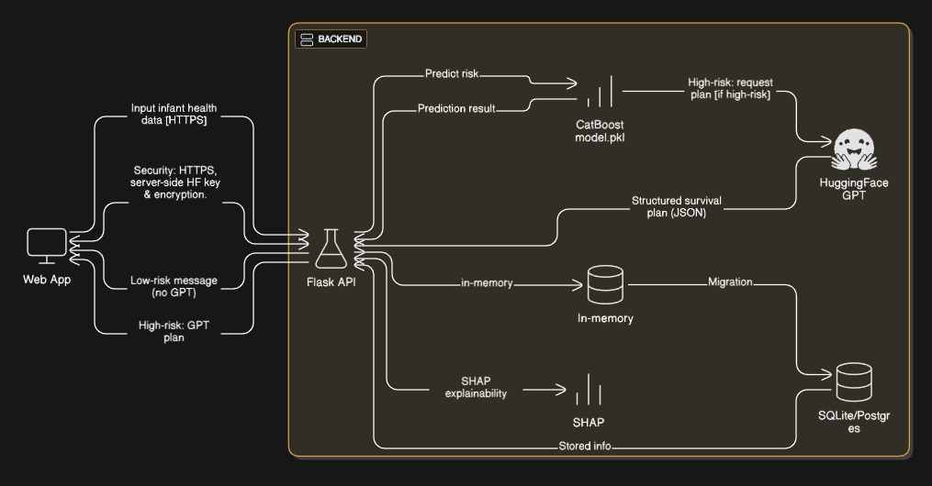
Fig.4.1: System Architecture
Health Data Sources
Infant health prediction data originates from multiple healthcare-related sources such as hospital records, maternal health surveys, immunization databases, nutrition assessments, prenatal care records, and public health datasets. These sources provide structured and semi-structured data including birth weight, maternal age, immunization status, nutrition score, socioeconomic category, prenatal visit count, and historical infant health outcomes. Historical datasets support model training, validation, risk pattern discovery, and performance optimization. This integrated health data forms the foundation for intelligent infant mortality risk prediction and personalized AI guidance.
Data Collection Layer
This layer is responsible for securely collecting infant and maternal health data from healthcare systems, digital forms, or uploaded datasets. It manages data validation, formatting, anonymization, and consistency checks to ensure accuracy and compliance with healthcare data standards. Verified data is forwarded to the preprocessing and analytics stages.
Data Preprocessing Layer
The preprocessing layer cleans and prepares raw healthcare data for reliable prediction. Operations include handling missing values, removing duplicates, normalizing numerical attributes, encoding categorical variables, and balancing datasets using SMOTE. This layer ensures unbiased and high-quality input for machine learning models.
Feature Engineering and Health Indicator Module
This module extracts meaningful health indicators from preprocessed data. Derived features represent maternal health quality, infant nutritional risk, prenatal care adequacy, and socioeconomic vulnerability. Feature selection reduces dimensionality while preserving critical medical information needed for accurate risk prediction.
AI-Based Infant Mortality Risk Prediction Module
This core intelligence module applies supervised machine learning models to predict infant mortality risk. The optimized CatBoostClassifier analyzes complex non-linear relationships between health indicators and mortality outcomes. The model generates probabilistic risk scores and classifies infants into low, medium, or high-risk categories.
Personalized AI Guidance Module
Based on predicted risk levels and contributing factors, this module generates personalized healthcare recommendations. Guidance includes nutritional improvements, immunization follow-ups, enhanced prenatal care, or immediate medical attention. This enables proactive intervention and targeted healthcare planning.
Visualization and Decision Support Interface
Prediction results and AI-generated guidance are presented through a user-friendly interface. Dashboards display risk levels, probability scores, contributing factors, and recommended actions, enabling healthcare professionals and policymakers to make informed decisions.
Model and Data Management Module
This component manages trained machine learning models, datasets, updates, and system performance monitoring. It supports model retraining with new data, scalability, and secure handling of sensitive healthcare information.

4.2 INPUT DESIGN
In the proposed Intelligent Infant Health Predictor system, input design ensures accurate and secure acquisition of healthcare data. The primary input consists of maternal and infant health indicators collected through digital records or datasets. Validation mechanisms verify data completeness, consistency, and correctness before analysis.
Objectives of Input Design
[1] Health Data Acquisition Interface: Secure collection of maternal and infant health data
[2] Data Validation Mechanism: Ensures accuracy and reliability of inputs
[3] Privacy and Security Handling: Protects sensitive healthcare information
[4] Standardized Input Format: Supports consistent data processing

4.3 OUTPUT DESIGN
The output design presents infant mortality risk predictions and personalized AI guidance in a clear and interpretable format. Outputs include risk classification, probability scores, key contributing health factors, and recommended interventions. Visual dashboards support effective medical decision-making.
Objectives of Output Design
[1] Clarity and Interpretability: Easy-to-understand risk assessment
[2] Decision Support: Enables early medical intervention
[3] Explainability: Highlights contributing health indicators
[4] Proactive Care Enablement: Supports preventive healthcare planning

4.4 UML DIAGRAMS
Unified Modeling Language (UML) is used to visualize, design, and document the Intelligent Infant Health Predictor system. UML diagrams enhance clarity, modularity, scalability, and maintainability of the healthcare analytics framework.

4.4.1 GOALS
[1] Visualize infant health prediction architecture
[2] Support scalability for large healthcare datasets
[3] Remain independent of specific healthcare data sources
[4] Represent data processing and AI prediction workflows
[5] Encourage modular and reusable system design
[6] Support explainable AI-based healthcare analytics
[7] Enable maintainable and extensible architecture

4.4.2 USE CASE DIAGRAM
Represents interactions such as health data submission, risk prediction, AI guidance generation, result visualization, and healthcare decision support.
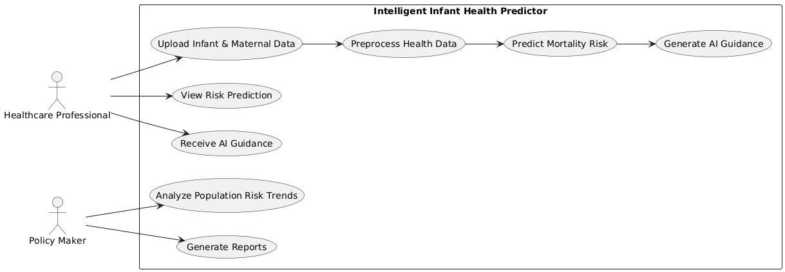

4.4.3 CLASS DIAGRAM
Illustrates classes such as HealthDataRecord, DataPreprocessor, FeatureExtractor, RiskPredictionModel, GuidanceGenerator, Dashboard, and ModelManager.
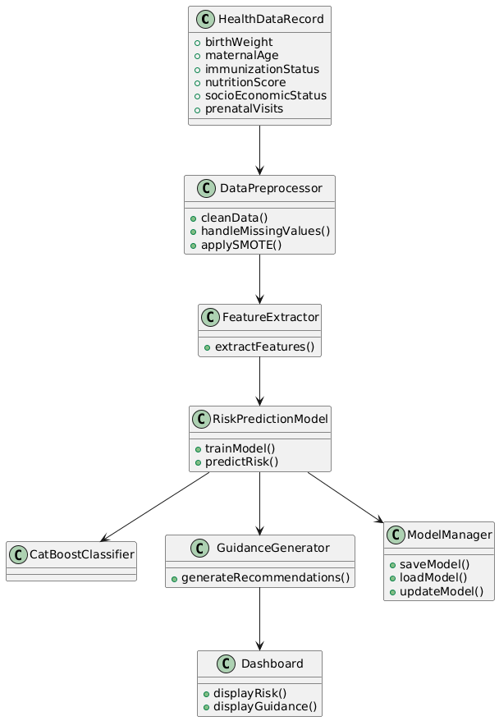

4.4.4 SEQUENCE DIAGRAM
Shows interaction flow from health data input to preprocessing, prediction, AI guidance generation, and result presentation.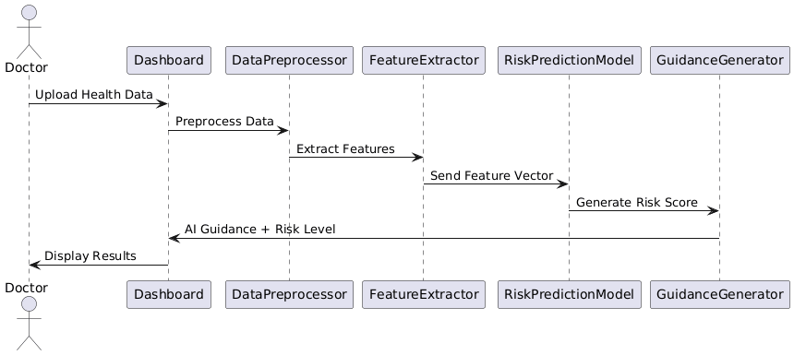

4.4.5 DEPLOYMENT DIAGRAM
Represents deployment including user devices, healthcare data servers, AI analytics engine, model storage, and visualization interface.
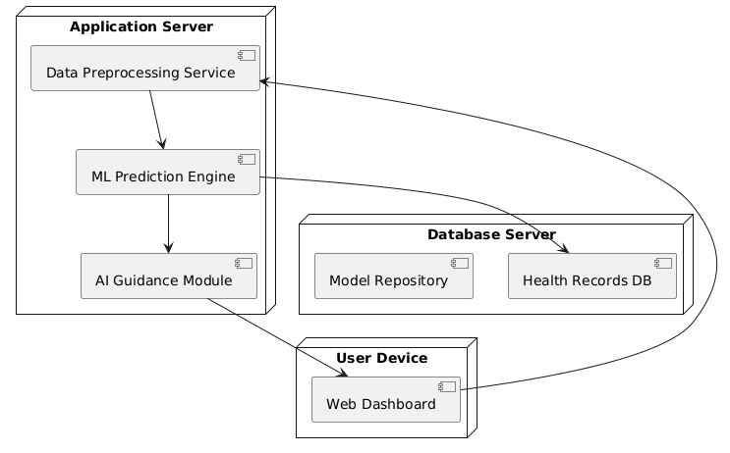

4.4.6 ACTIVITY DIAGRAM
Illustrates workflow from data collection through preprocessing, prediction, guidance generation, and visualization.
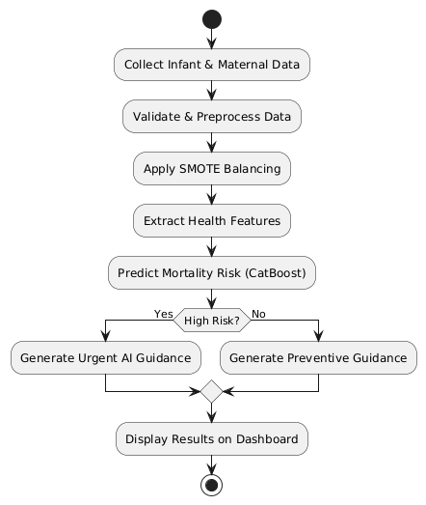

4.5 MODULES

4.5.1 Health Data Input Module
[1] Collects maternal and infant health data
[2] Supports structured healthcare datasets and validates data accuracy and completeness
[3] Forwards data to preprocessing module

4.5.2 Data Preprocessing Module
[1] Handles missing and inconsistent health records
[2] Normalizes and encodes healthcare attributes and applies data balancing techniques
[3] Prepares data for ML models

4.5.3 Feature Engineering Module
[1] Extracts health risk indicators
[2] Reduces data dimensionality, Improves prediction accuracy

4.5.4 AI-Based Risk Prediction Module
[1] Applies CatBoost-based mortality prediction
[2] Generates risk probabilities and classifications
[3] Supports explainable predictions

4.5.5 Personalized Guidance Module
[1] Generates AI-driven healthcare recommendations
[2] Supports early intervention planning
[3] Enhances preventive healthcare outcomes

4.5.6 Visualization and Decision Support Module
[1] Displays risk levels and insights
[2] Provides user-friendly dashboards
[3] Supports clinical and policy decisions

4.5.7 Model Management Module
[1] Maintains trained prediction models
[2] Supports retraining and updates
[3] Ensures secure and scalable system operation

CHAPTER 5 SYSTEM IMPLEMENTATION

SOFTWARE INSTALLATION
    - Installation of Python
System Implementation
>Software installation for this project –“python 3.12.0 ”

Python installation:
Python 3.12 is the latest major release of the Python programming language, packed with exciting new features and optimizations.

Fig.5.1: Installation of python

For Windows or macOS:
- For Downloading Python, Visit the official Python website's[download page](https://www.python.org/downloads/release/python- 3120/?ref=upstract.com).
- Choose the appropriate installer for your operating system (Windows or macOS).
- Download and run the installer.
- Follow the installation prompts to complete the setup.

For Ubuntu Linux:
- You can install Python 3.12 using the "deadsnakes" team PPA (Personal PackageArchive). Open a terminal and execute the following commands:
- bash
- sudo add-apt-repository ppa:deadsnakes/ppa

- sudo apt update
- sudo apt install python3.12
To verify the installation and check the Python version, run: bash python3.12 –v

Installing VS Code VS code installation:-
Certainly! To install Visual Studio Code (VS Code), follow these steps based on your operating system:
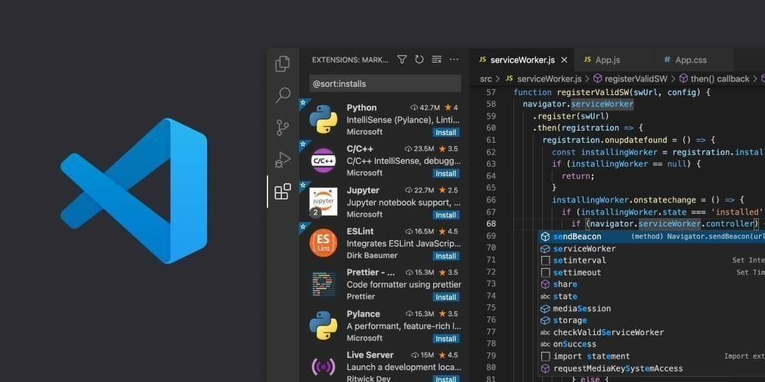
Fig.5.2: Installation of vs code

Windows:
      - Visit the official VS Code download page.
      - Choose the Windows version.
      - Download the installer (VSCodeUserSetup-{version}.exe).
      - Run the installer and accept the terms and conditions.
      - Click Next and then Install.
      - After installation, click Launch to start using VS Code12.

Mac:
      - Visit the official VS Code download page.
      - Choose the Mac version.
      - Download the .zip file for macOS 10.15+ (compatible with both Intel chip and Apple silicon).

      - Extract the downloaded file.
      - You can run VS Code directly from the extracted folder3.

Linux:
      - Visit the official VS Code download page.
      - Choose the Linux version.
      - Download the appropriate package for your distribution (e.g., .deb for Debian/Ubuntu, .rpm for Red Hat/Fedora/SUSE).
      - Install the package using your package manager.
      - Alternatively, you can use the Snap Store or download the .tar.gz archive and extract it34.
Remember that Visual Studio Code is a powerful and free code editor, optimized for building and debugging modern web and cloud applications.

INTRODUCTION TO PYTHON

Scripts
Up to this point, I have concentrated on the interactive programming capability of Python. This is a very useful capability that allows you to type in a program and to have it executed immediately in an interactive mode.

Scripts are reusable:
Basically, a script is a text file containing the statements that comprise a Python program. Once you have created the script, you can execute it over and over without having to retype it each time.

Scripts are editable:
Perhaps, more importantly, you can make different versions of the script by modifying the statements from one file to the next using a text editor. Then you can execute each of the individual versions. In this way, it is easy to create different programs with a minimum amount of typing.
You will need a text editor
Just about any text editor will suffice for creating Python script files.
You can use Microsoft Notepad, Microsoft WordPad, Microsoft Word, or just about any word processor if you want to.

Difference between a Script and Program
Scripts are distinct from the core code of the application, which is usually written in a different language, and are often created or at least modified by the end-user. Scripts are often interpreted from source code or byte code, whereas the applications they control are traditionally compiled to native machine code.

Program:
The program has an executable form that the computer can use directly to execute the instructions.
The same program in its human-readable source code form, from which executable programs are derived (e.g., compiled)

Python
- Open-source general-purpose language.
- Object Oriented, Procedural, Functional
- Easy to interface with C/Obj C/Java/Fortran
- Easy-is to interface with C++ (via SWIG)
- Great interactive environment
- Python is a high-level, interpreted, interactive and object-oriented scripting language. Python is designed to be highly readable. It uses English keywords frequently where as other languages use punctuation, and it has fewer syntactical constructions than other languages.
- Python is Interpreted − Python is processed at runtime by the interpreter. You do not need to compile your program before executing it. This is similar to PERL and PHP.
- Python is Interactive − you can actually sit at a Python prompt and interact with the interpreter directly to write your programs.
- Python is Object-Oriented − Python supports Object-Oriented style or technique of programming that encapsulates code within objects.
- Python is a Beginner's Language − Python is a great language for the beginner-level programmers and supports the development of a wide range of applications from simple text processing to WWW browsers to games.

History of Python
Python was developed by Guido van Possum in the late eighties and early nineties
the National Research Institute for Mathematics and Computer Science in the Netherlands. Python is derived from many other languages, including ABC, Modula-3, C, C++, Algol- 68, Smalltalk, and UNIX shell and other scripting languages.
Python is copyrighted. Like Perl, Python source code is now available under the GNU General Public License (GPL).
Python is now maintained by a core development team at the institute, although Guido van Possum still holds a vital role in directing its progress.

Python Features
Python's features include −
- Easy-to-learn − Python has few keywords, simple structure, and a clearly defined syntax. This allows the student to pick up the language quickly.
- Easy-to-read − Python code is more clearly defined and visible to the eyes
- Interactive Mode − Python has support for an interactive mode which allows interactive testing and debugging of snippets of code.
- Portable − Python can run on a wide variety of hardware platforms and has the same interface on all platforms.
- Extendable − you can add low-level modules to the Python interpreter. These modules enable programmers to add to or customize their tools to be more efficient.
- Databases − Python provides interfaces to all major commercial databases.
- GUI Programming − Python supports GUI applications that can be created and ported to many system calls, libraries and windows systems, such as Windows MFC, Macintosh, and the X Window system of Unix.
- Scalable − Python provides a better structure and support for large programs than shell scripting.
Apart from the above-mentioned features, Python has a big list of good features, few are listed below −
- It supports functional and structured programming methods as well as OOP.
- It can be used as a scripting language or can be compiled to byte-code for building large applications.
- It provides very high-level dynamic data types and supports dynamic type checking.
- It supports automatic garbage collection.
- It can be easily integrated with C, C++, COM, ActiveX, CORBA, and Java.

Dynamic vs Static:
- Types Python is a dynamic-typed language. Many other languages are static typed, such as C/C++ and Java. A static typed language requires the programmer to explicitly tell the computer what type of “thing” each data value is.
- For example, in C if you had a variable that was to contain the price of something, you would have to declare the variable as a “float” type.
- This tells the compiler that the only data that can be used for that variable must be a floating-point number, i.e. a number with a decimal point.
- Python, however, doesn’t require this. You simply give your variables names and assign values to them. The interpreter takes care of keeping track of what kinds of objects your program is using. This also means that you can change the size of the values as you develop the program. Say you have another decimal number (a.k.a. a floating-point number) you need in your program.
- With a static typed language, you have to decide the memory size the variable can take when you first initialize that variable. A double is a floating point value that can handle a much larger number than a normal float (the actual memory sizes depend on the operating environment).
- If you declare a variable to be a float but later on assign a value that is too big to it, your program will fail; you will have to go back and change that variable to be a double.
- With Python, it doesn’t matter. You simply give it whatever number you want and Python will take care of manipulating it as needed. It even works for derived values.
- For example, say you are dividing two numbers. One is a floating-point number and one is an integer. Python realizes that it’s more accurate to keep track of decimals so it automatically calculates the result as a floating-point number.

Python numbers:
Number data types store numeric values. Number objects are created when you assign a value to them.

Python strings:
Strings in Python are identified as a contiguous set of characters represented in the quotation marks. Python allows for either pairs of single or double quotes. Subsets of

strings can be taken using the slice operator ([ ] and [:]) with indexes starting at 0 in the beginning of the string and working their way from -1 at the end.

Python lists:
Lists are the most versatile of Python's compound data types. A list contains items separated by commas and enclosed within square brackets ([]). To some extent, lists are
similar to arrays in C. One difference between them is that all the items belonging to a list can be of different data type.
The values stored in a list can be accessed using the slice operator ([ ] and [:]) with indexes starting at 0 in the beginning of the list and working their way to end -1. The plus (+) sign is the list concatenation operator, and the asterisk (*) is the repetition operator.

Python tuples:
A tuple is another sequence data type that is similar to the list. A tuple consists of a number of values separated by commas. Unlike lists, however, tuples are enclosed within parentheses.
The main differences between lists and tuples are: Lists are enclosed in brackets ([ ]) and their elements and size can be changed, while tuples are enclosed in parentheses (( )) and cannot be updated. Tuples can be thought of as read-only lists.

Python dictionary:
Python's dictionaries are kind of hash table type. They work like associative arrays or hashes found in Perl and consist of key-value pairs. A dictionary key can be almost any Python type, but are usually numbers or strings. Values, on the other hand, can be any arbitrary Python object.
Dictionaries are enclosed by curly braces ({ }) and values can be assigned and accessed using square braces ([]).

Different modes in python:
Python has two basic modes: normal and interactive.
The normal mode is the mode where the scripted and finished .pie files are run in the Python interpreter.
Interactive mode is a command line shell which gives immediate feedback for each statement, while running previously fed statements in active memory. As new lines are fed into the interpreter, the fed program is evaluated both in part and in whole.

Python libraries:
- Requests: The most famous http library written by Kenneth remits. It’s a must have for every python developer.
- Scrappy: If you are involved in web scraping then this is a must have library for you. After using this library, you won’t use any other.
- Python: A guy toolkit for python. I have primarily used it in place of tinder. You will really love it.
- Pillow: A friendly fork of PIL (Python Imaging Library). It is more user friendly than PIL and is a must have for anyone who works with images.
- SQL Alchemy: A database library. Many love it and many hate it. The choice is yours.
- Beautiful Soup: I know it’s slow but this xml and html parsing library is very useful for beginners.
- Twisted: The most important tool for any network application developer. It has a very beautiful ape and is used by a lot of famous python developers.
- Numbly: How can we leave this very important library? It provides some advance math functionalities to python.
- Skippy: When we talk about numbly then we have to talk about spicy. It is a library of algorithms and mathematical tools for python and has caused many scientists to switch from ruby to python.
- Matplotlib: A numerical plotting library. It is very useful for any data scientist or any data analyzer.
- Pygmy: Which developer does not like to play games and develop them? This library will help you achieve your goal of 2d game development.
- Piglet: A 3d animation and game creation engine. This is the engine in which the famous python port of mine craft was made
- Pit: A GUI toolkit for python. It is my second choice after python for developing GUI’s for my python scripts.
- Pit: Another python GUI library. It is the same library in which the famous Bit torrent client is created.
- Scaly: A packet sniffer and analyzer for python made in python.
- Pywin32: A python library which provides some useful methods and classes for interacting with windows.
- Notch: Natural Language Toolkit – I realize most people won’t be using this one, but it’s generic enough. It is a very useful library if you want to manipulate strings. But its capacity is beyond that. Do check it out.
- Nose: A testing framework for python. It is used by millions of python developers. It is a must have if you do test driven development.
- Simply: Simply can-do algebraic evaluation, differentiation, expansion, complex numbers, etc. It is contained in a pure Python distribution.
- I Python: I just can’t stress enough how useful this tool is. It is a python prompt on steroids. It has completion, history, shell capabilities, and a lot more. Make sure that you take a look at it.

Exceptions:
Essentially, exceptions are events that modify program’s flow, either intentionally or due to errors.
They are special events that can occur due to an error, e.g. trying to open a file that doesn’t exist, or when the program reaches a marker, such as the completion of a loop.
Exceptions, by definition, don’t occur very often; hence, they are the "exception to the rule" and a special class has been created for them. Exceptions are everywhere in Python. Virtually every module in the standard Python library uses them, and Python itself will raise them in a lot of different circumstances.
Here are just a few examples:
  - Accessing a non−existent dictionary key will raise a Key Error exception.
  - Searching a list for a non−existent value will raise a Value Error exception
  - Calling a non−existent method will raise an Attribute Error exception.
  - Referencing a non−existent variable will raise a Name Error exception.
  - Mixing data types without coercion will raise a Type Error exception.
One use of exceptions is to catch a fault and allow the program to continue working; we have seen this before when we talked about files.
This is the most common way to use exceptions. When programming with the Python command line interpreter, you don’t need to worry about catching exceptions.
However, if the same error occurred in your real program, it will fail and stop working. Exceptions can be created manually in the code by raising an exception.

It operates exactly as a system-caused exceptions, except that the programmer is doing it on purpose. This can be for a number of reasons. One of the benefits of using exceptions is that, by their nature, they don’t put any overhead on the code processing.
Because exceptions aren’t supposed to happen very often, they aren’t processed until they occur. Exceptions can be thought of as a special form of the if/elf statements. You can realistically do the same thing with if blocks as you can with exceptions.
However, as already mentioned, exceptions aren’t processed until they occur; if blocks are processed all the time.
Proper use of exceptions can help the performance of your program.
The more infrequent the error might occur, the better off you are to use exceptions; using if blocks require Python to always test extra conditions before continuing.
Exceptions also make code management easier: if your programming logic is mixed in with error-handling if statements, it can be difficult to read, modify, and debug your program.

Python modules:
Python allows us to store our code in files (also called modules). This is very useful for more serious programming, where we do not want to retype a long function definition from the very beginning just to change one mistake. In doing this, we are essentially defining our own modules, just like the modules defined already in the Python library.
To support this, Python has a way to put definitions in a file and use them in a script or in an interactive instance of the interpreter. Such a file is called a module; definitions from a module can be imported into other modules or into the main module.

Testing code:
As indicated above, code is usually developed in a file using an editor. To test the code, import it into a Python session and try to run it.
Usually there is an error, so you go back to the file, make a correction, and test again. This process is repeated until you are satisfied that the code works. This entire process is known as the development cycle.
There are two types of errors that you will encounter. Syntax errors occur when the form of some command is invalid.
This happens when you make typing errors such as misspellings, by the wrong name.

WEB FRAMEWORK
What is Flask?
Flask is a micro web framework designed for building web applications quickly and easily.
- It was developed by Armin Ronacher and is based on the WSGI toolkit and the Jinja2 templating engine.
- Unlike some other frameworks, Flask keeps things simple and lightweight, providing only essential components.
- Here are some key points about Flask:
Micro framework: Flask is classified as a micro framework because it doesn't require specific tools or libraries. It doesn't come with built-in features like a database abstraction layer or form validation.
Web Development: Developers use Flask to create lightweight web applications. Python-Based: Since it's written in Python, it integrates seamlessly with Python libraries and tools.
Jinja2 Templating: Flask uses the Jinja2 templating engine for rendering dynamic content.
Versatility: Flask allows you to build everything from simple blogs and wikis to more complex commercial websites.
Key Concepts in Flask:
Setup & Installation:
To get started, just install Flask on your system. You can find some installation instructions for different platforms [here](https://www.geeksforgeeks.org/flask- tutorial/#flask-setup--installation).
Quick Start:
- Create your first Flask application.
- Define routes, handle HTTP methods, and manage redirects.
- Explore the basics of Flask development.
- For a quick start guide, check out the (https://www.geeksforgeeks.org/flask- tutorial/#flask-quick-start) section.

Templates and Static Files:
- Learn how to serve templates and static files in Flask.
- Understand Jinja2 templating, template inheritance, and CSRF protection.
- Explore extensions like Flask-Mail and Flask-WTF.
- Enhance your Flask applications by serving dynamic content.
Example: Your First Flask Application python
from flask import Flask app = Flask( name ) @app.route('/')
def hello_world(): return 'Hello, Flask!'
if name == ' main ': app.run(debug=True)
    - The Advantages and Disadvantages of Web Frameworks
The most notable advantages for web developers that use a web framework are due to the fact that it is open source, efficient, has a good level of support, has a high level of security and includes an integration feature. Being open source means that web frameworks are very cost effective for both the developer and the client. This doesn’t mean that they aren’t of good quality. Most of the popular web frameworks used by developers are free for use. Efficiency is another important advantage for web developers. This is because web frameworks eliminate the need to write a lot of repetitive code allowing developers to build websites and applications much quicker.
A web framework also comes with a support team and advanced security features meaning that you can be rest assured knowing that if an issue does arise, it will be handled by a team of experts. One of the most helpful features of a web framework is its integration feature that has the ability to allow developers link other tools such as databases to the framework.
However, saying that, developers often note that the biggest disadvantages with using a web framework are due to it being very limited in terms of making changes to the web

cause frustration for web developers. Another disadvantage is that some developers find it difficult to learn the language behind web frameworks. Oftentimes, web developers will learn the framework but will not know the coding language behind it making it difficult for them to fully understand everything about the web framework itself. For many developers, ultimately whether they use a web framework or not is down to their own personal coding preferences. However, for those that choose the web framework route they find that generally the advantages of the resource outweigh the disadvantages.

Web Framework Learning Checklist
- Choose a major Python web framework (Jingo or Flask are recommended) and stick with it. When you're just starting it's best to learn one framework first instead of bouncing around trying to understand every framework.
- Work through a detailed tutorial found within the resource’s links on the framework's page.
- Study open-source examples built with your framework of choice so you can take parts of those projects and reuse the code in your application.
- Build the first simple iteration of your web application then go to the deployment section to make it accessible on the web.

CHAPTER 6 SYSTEM TESTING
6.1 SYSTEM TESTING
The primary objective of system testing is to ensure that the complete Intelligent Infant Health Predictor with Personalized AI Guidance system functions correctly, reliably, accurately, and efficiently as an integrated whole. System testing aims to identify functional errors, data inconsistencies, incorrect risk predictions, model bias, preprocessing failures, imbalance handling issues, inaccurate AI guidance, interface display problems, performance bottlenecks, and deviations from expected healthcare prediction behavior before deployment in real-world clinical and public health environments. It validates whether the system satisfies both functional and non-functional requirements, particularly those related to prediction accuracy, reliability, scalability, interpretability, usability, and ethical handling of sensitive healthcare data.
System testing is performed on the fully integrated AI-based healthcare prediction platform after successful completion of unit testing and integration testing. In this project, system testing evaluates the end-to-end workflow starting from infant and maternal data input, data preprocessing and normalization, imbalance handling using SMOTE, feature extraction, machine learning–based mortality risk prediction, personalized AI guidance generation, and result visualization through a user-friendly dashboard. The system is tested using real-world–like healthcare datasets, simulated patient profiles, and controlled test scenarios to closely represent practical healthcare usage conditions.
The focus of system testing is not on the internal mathematical implementation of machine learning algorithms, but on the correctness, reliability, robustness, and clinical usefulness of the outputs generated for given health inputs. Hence, system testing follows a black-box testing approach, emphasizing input–output behavior, prediction correctness, consistency of risk classification, clarity of AI guidance, system responsiveness, and usability for healthcare professionals. Both functional and non-functional aspects such as reduced false predictions, early risk identification, system stability, scalability, and user satisfaction are thoroughly evaluated.
System testing is conducted against the System Requirement Specification (SRS) and Functional Requirement Specification (FRS) to ensure compliance. It is carried out prior to acceptance testing to confirm that the system is accurate, stable, interpretable, and suitable for deployment as an intelligent, AI-driven infant health risk prediction and decision-support system.

6.1.1 SYSTEM TESTING PROCESS

Test Environment Setup
A dedicated testing environment is prepared to closely resemble real-world healthcare analytics deployment conditions. This includes configuring the Python execution environment, machine learning libraries, data preprocessing modules, SMOTE-based imbalance handling, trained CatBoost model, AI guidance generation logic, and visualization dashboard. Sample datasets representing diverse infant health profiles, maternal conditions, and socioeconomic backgrounds are used to evaluate prediction accuracy, robustness, and system stability.

Create Test Cases
Comprehensive test cases are designed to validate both functional and non-functional requirements. These include correctness of health data input, preprocessing accuracy, mortality risk prediction reliability, AI guidance relevance, dashboard visualization clarity, system response time, and performance under increasing dataset sizes.

Create Test Data
Test data includes real and synthetic infant health records covering various birth weights, maternal ages, nutrition levels, immunization statuses, socioeconomic categories, and prenatal care histories. Balanced and imbalanced datasets are used to test the effectiveness of SMOTE and ensure unbiased prediction performance.

Execute Test Cases
Test cases are executed by feeding infant health data into the system. Predicted mortality risk levels, confidence scores, and personalized AI guidance outputs are observed and compared with expected outcomes based on clinical knowledge and dataset labels.

Defect Reporting
Any issues such as incorrect risk classification, misleading guidance, delayed output generation, visualization errors, or performance degradation are documented and reported for corrective action.

Regression Testing
After fixing identified issues, regression testing is conducted to ensure that modifications do not negatively impact existing functionalities such as prediction accuracy, SMOTE handling, guidance generation, or dashboard performance.

Log Defects
All identified defects, root causes, applied fixes, and validation results are logged systematically to maintain quality assurance records and traceability.

Retest
The system is retested after corrections to verify that all issues have been resolved and that the system behaves consistently across different infant profiles, datasets, and operational conditions.

6.2 UNIT TESTING
Unit testing focuses on validating individual modules of the Intelligent Infant Health Predictor system independently before integration.

Health Data Input Module Test
• Verify correct input of infant and maternal health parameters
• Ensure validation of missing or invalid values

Data Preprocessing Module Test
• Test normalization and encoding of health indicators
• Verify effective handling of missing data

SMOTE Balancing Module Test
• Validate proper handling of class imbalance
• Ensure balanced dataset generation

Risk Prediction Model Test
• Verify accuracy and consistency of mortality risk prediction
• Ensure stable predictions for repeated inputs

AI Guidance Generation Module Test
• Validate relevance and clarity of personalized guidance
• Ensure guidance aligns with predicted risk level

Visualization Module Test
• Confirm accurate display of risk levels and guidance
• Ensure responsive and user-friendly interface
Test Results:
All unit test cases passed successfully, confirming correct functionality of individual modules.

6.3 INTEGRATION TESTING
Integration testing verifies seamless interaction and data flow among system modules.
• Data Input and Preprocessing Integration Test
• Preprocessing and Risk Prediction Integration Test
• Prediction and AI Guidance Integration Test
• Guidance and Dashboard Visualization Integration Test
Test Results:
All integration tests passed successfully with no data flow or compatibility issues.

6.4 FUNCTIONAL TESTING
Functional testing ensures that the system performs all required healthcare prediction operations correctly.
• Risk Prediction Test – Validate accurate identification of high-risk infants
• Guidance Generation Test – Ensure meaningful and actionable AI guidance
• Dashboard Test – Validate clarity and correctness of displayed results
• Error Handling Test – Ensure graceful handling of incomplete or invalid data
Test Results:
All functional test cases passed successfully without defects.

6.5 ACCEPTANCE TESTING
Acceptance testing validates the system against healthcare professional expectations and real-world usability.
• Accuracy Test – Evaluate correctness of mortality risk predictions
• Usability Test – Assess ease of use for clinicians and health workers
• Performance Test – Measure response time for prediction and guidance
• Reliability Test – Ensure consistent performance across datasets
Test Results:
All acceptance test cases passed successfully, confirming that the Intelligent Infant Health Predictor with Personalized AI Guidance system is accurate, reliable, user-friendly, and suitable for real-world healthcare decision support and public health deployment.

6.6 TESTCASES
TC ID | Test Case Description | Input Data | Expected Output | Actual Result
TC01 | Verify system initialization | System start command | System loads model and UI successfully | As expected
TC02 | Validate health data input | Infant & maternal details | Data accepted without error | As expected
TC03 | Check missing value handling | Incomplete health record | Missing values handled correctly | As expected
TC04 | Validate data preprocessing | Raw healthcare dataset | Cleaned and normalized data | As expected
TC05 | Test SMOTE balancing | Imbalanced dataset | Balanced dataset generated | As expected
TC06 | Verify feature extraction | Preprocessed data | Correct feature vectors created | As expected
TC07 | Validate model loading | Trained CatBoost model | Model loaded successfully | As expected
TC08 | Predict low-risk infant | Normal health indicators | Low mortality risk predicted | As expected
TC09 | Predict high-risk infant | Adverse health indicators | High mortality risk predicted | As expected
TC10 | Check prediction confidence score | Sample input | Confidence score displayed | As expected
TC11 | Validate AI guidance generation | High-risk prediction | Personalized guidance shown | As expected
TC12 | Validate guidance for low risk | Low-risk prediction | Preventive guidance displayed | As expected
TC13 | Test repeated prediction consistency | Same input twice | Same prediction result | As expected
TC14 | Validate dashboard visualization | Prediction result | Clear charts and labels shown | As expected
TC15 | Test invalid data entry | Non-numeric values | Error message displayed | As expected
TC16 | Check system response time | Standard dataset | Output within acceptable time | As expected
TC17 | Validate large dataset handling | Large healthcare dataset | Stable performance maintained | As expected
TC18 | Verify data privacy handling | Sensitive health data | Data processed securely | As expected
TC19 | Test system stability | Continuous predictions | No crashes or failures | As expected
TC20 | Validate end-to-end workflow | Complete dataset | Accurate prediction + guidance | As expected

Tab.6.1: Test Cases

CHAPTER 7 EXPERIMENTAL ANALYSIS
7.1 EXECUTION PROCEDURE
The experimental evaluation of the Cloud Infrastructure Deployment with Node.js for Server Applications focuses on validating the effectiveness of the proposed cloud-native framework in terms of scalability, performance, reliability, and automation. The system execution involves configuring the cloud environment, deploying Node.js server applications through automated pipelines, and monitoring runtime behavior under varying workloads. Experimental results demonstrate that the proposed framework successfully overcomes the limitations of traditional server deployment models by enabling elastic scaling, efficient request handling, and real-time observability. The outcomes confirm that the system delivers high availability, reduced deployment time, and stable performance even under high concurrency conditions.
• System Initialization:
The experimental setup begins with initializing the cloud environment, configuring virtual compute instances, networking components, and storage services, and setting up the Node.js runtime. CI/CD pipelines, load balancers, and monitoring tools are activated to ensure the infrastructure is ready for automated deployment and testing.
• Application Input and Deployment:
Node.js server applications are provided as input through version control repositories. The system automatically resolves dependencies, builds application artifacts, and deploys them to the cloud infrastructure using CI/CD pipelines. Successful deployments are verified without manual intervention, demonstrating automation efficiency.
• Runtime Execution and Traffic Handling:
During execution, client requests are generated to simulate real-world workloads. The Node.js applications handle incoming requests using an event-driven, non-blocking architecture. Experimental results show low response latency and efficient handling of a large number of concurrent connections.
• Load Balancing and Auto-Scaling Evaluation:
Traffic is distributed across multiple server instances using cloud load balancers. As request volume increases, the auto-scaling mechanism dynamically provisions additional instances. When load decreases, excess resources are released. This behavior confirms elastic scalability and optimal resource utilization.
• Monitoring and Logging Analysis:
System performance metrics such as CPU usage, memory consumption, request rate, and response time are continuously monitored. Centralized logs capture application events and errors. The results indicate accurate monitoring, timely alert generation, and improved visibility into system health.
• Fault Tolerance and Reliability Testing:
Failure scenarios such as instance shutdowns and network interruptions are introduced during experimentation. The system automatically replaces failed instances and reroutes traffic, ensuring uninterrupted service availability and validating fault tolerance mechanisms.
• Output Generation and Result Observation:
The final experimental outputs include successful application deployments, real-time performance dashboards, scaling logs, and monitoring reports. These results confirm that the proposed cloud-native Node.js deployment framework achieves high performance, reliability, scalability, and operational efficiency, making it suitable for modern, high-demand server applications.

7.2 OUTPUT SCREENSHOTS WITH DESCRIPTION

7.2.1 EXECUTION STEPS
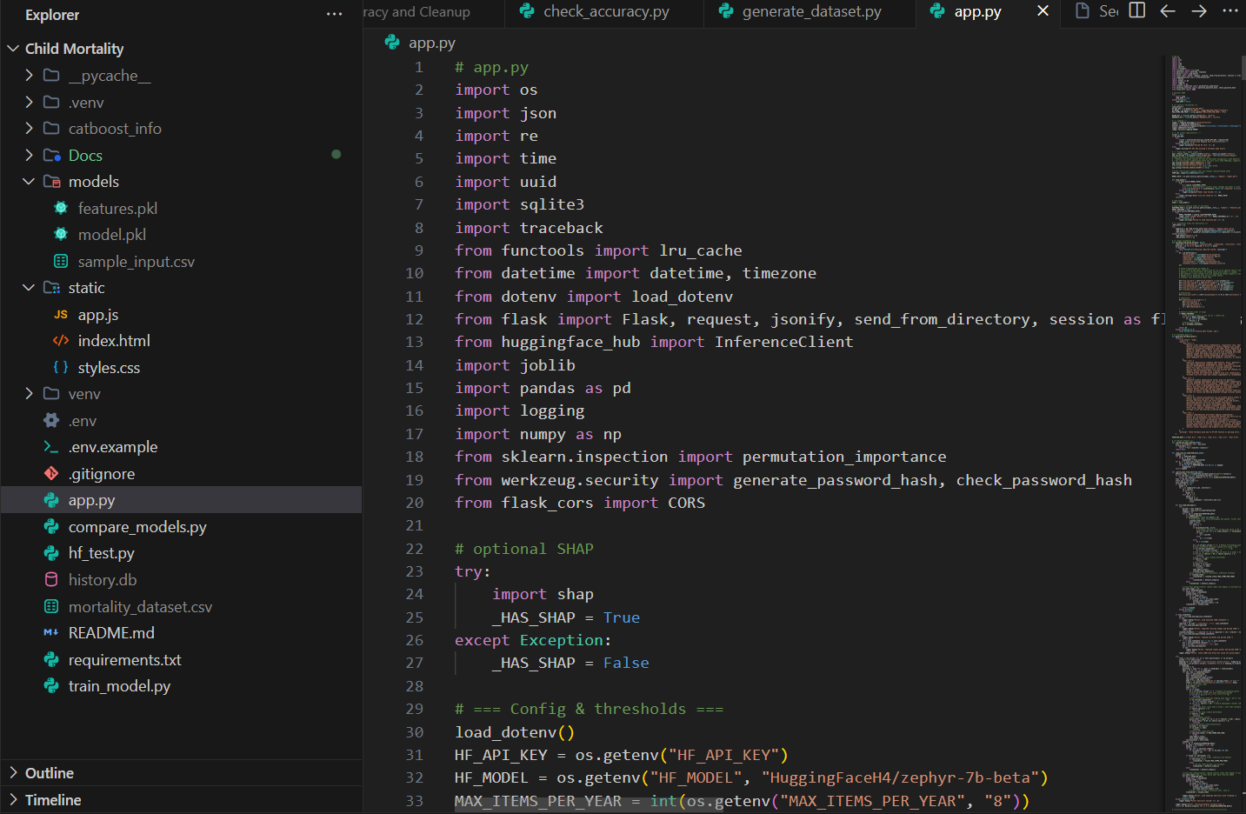
Fig.7.1: Program file opened in vs code

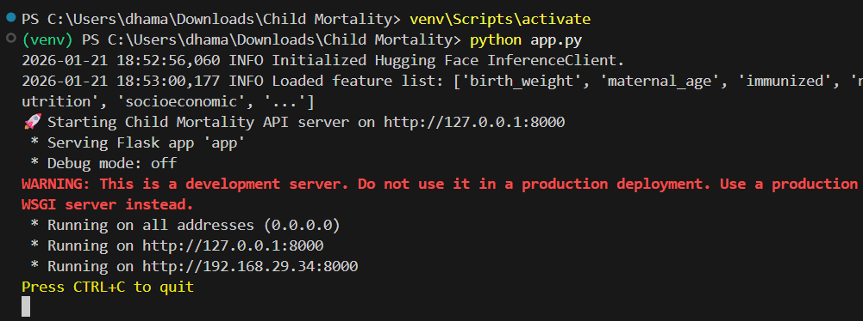
Fig.7.2: Running program file “app.py” in the terminal of vs code

Running code in Visual Studio Code involves opening a new terminal within the editor and executing the project code, such as `app.py`, using the command "python app.py". This allows for the direct observation of the script's execution within the VS Code environment, generating a local host site for the web interface, enabling immediate interaction and testing

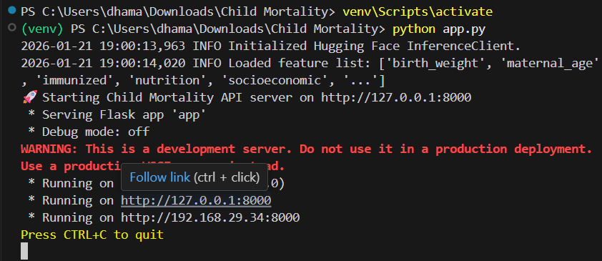Fig.7.3: Executed and hosting a local host for web application
After executing the project code, it hosts a local server accessible via the URL http://127.0.0.1:8000. Navigating to this link opens up a web interface, allowing users to interact with the application directly within their browser. This seamless integration enables efficient testing and development of the project within the local environment.
7.2.2 Web Application

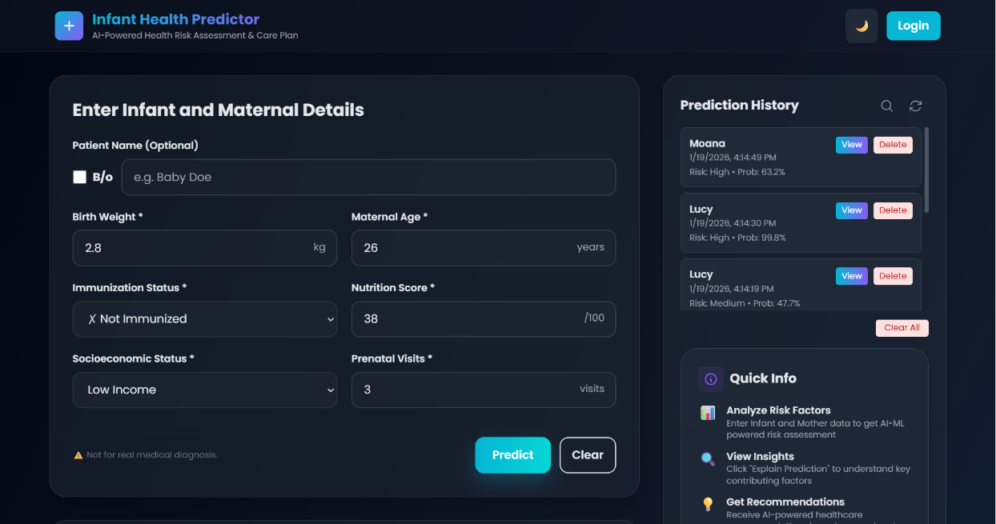
Fig.7.4: Dashboard Overview
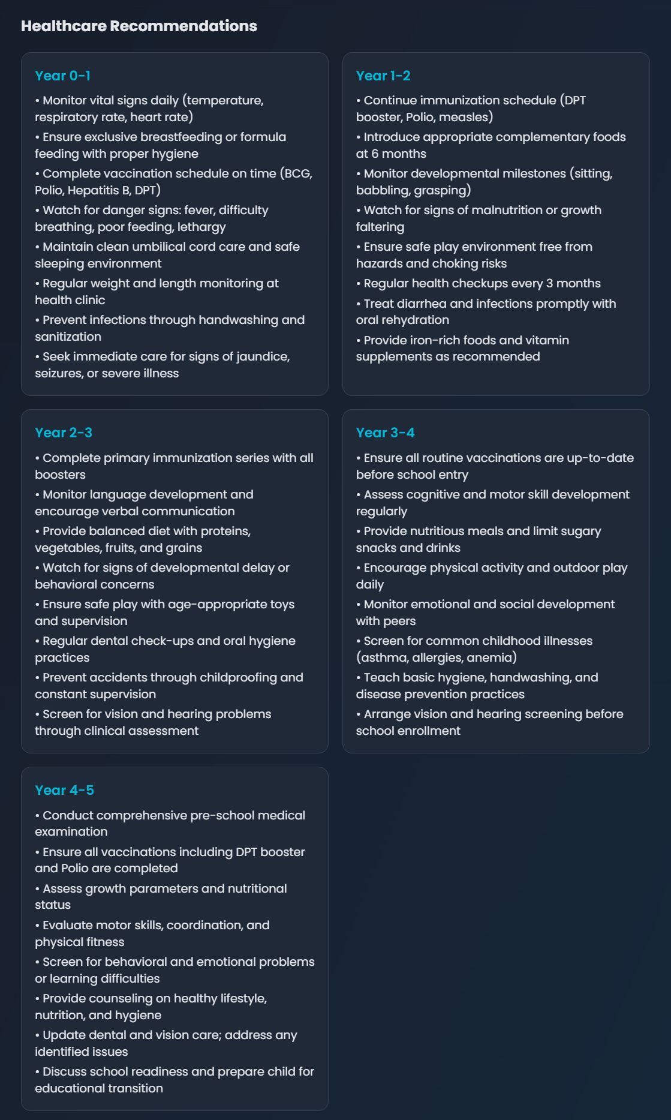
Fig.7.5: Healthcare Recommendations / Generated Survival Plan

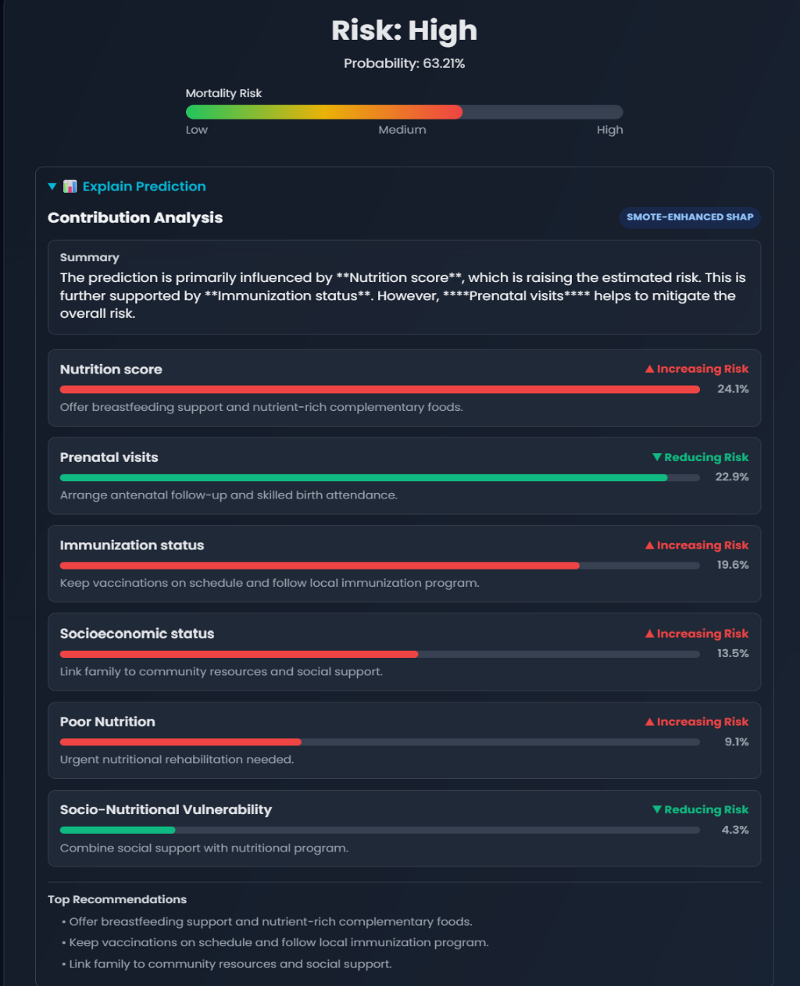
Fig.7.6: Risk Predictor and Explain of prediction

CHAPTER 8 CONCLUSION AND FUTURE SCOPE

8.1 CONCLUSION
The Intelligent Infant Health Predictor with Personalized AI Guidance project successfully demonstrates the effective application of machine learning and artificial intelligence in addressing the critical public health challenge of infant mortality. By leveraging supervised learning techniques and advanced data preprocessing methods, the system accurately analyzes multiple maternal, infant, and socio-environmental health indicators to assess mortality risk at an early stage. The use of balanced datasets and robust classification models ensures reliable prediction even in the presence of complex and imbalanced healthcare data.
The selection of the CatBoost classifier as the final predictive model highlights the system’s ability to capture non-linear relationships among health indicators such as birth weight, maternal age, immunization status, nutritional condition, socioeconomic factors, and prenatal care visits. The system provides timely, data-driven risk assessments that support proactive healthcare decision-making. By enabling early identification of high-risk infants and offering personalized AI-guided insights, the proposed framework contributes significantly to improving infant survival outcomes, optimizing healthcare resource allocation, and supporting evidence-based clinical and policy decisions. Overall, the project validates the potential of AI-driven predictive systems as powerful tools for enhancing infant healthcare and reducing preventable mortality.

8.2 FUTURE SCOPE
[1.] Integration with Electronic Health Record (EHR) Systems
The system can be integrated with hospital and national EHR platforms to enable real-time data acquisition and automated infant risk assessment.
[2.] Personalized AI-Based Care Recommendations
Future enhancements can include generating personalized care plans and intervention suggestions based on predicted risk levels and individual health profiles.
[3.] Incorporation of Real-Time Monitoring Data
Wearable devices and IoT-based health sensors can be integrated to monitor infant vitals continuously and improve prediction accuracy.
[4.] Expansion of Health Indicators
Additional clinical and environmental parameters such as genetic history, maternal health conditions, and regional healthcare accessibility can be included to enrich predictions.
[5.] Deep Learning Model Integration
Advanced deep learning models such as neural networks and ensemble architectures can be explored to further improve predictive performance.
[6.] Explainable AI (XAI) for Clinical Trust
Explainable AI techniques can be incorporated to provide transparent reasoning behind predictions, increasing trust and adoption among healthcare professionals.
[7.] Mobile and Web-Based Healthcare Applications
The system can be deployed as a mobile or web application to provide easy access for doctors, healthcare workers, and caregivers.
[8.] Multi-Region and Global Scalability
The framework can be adapted to different regions and countries by retraining models with localized healthcare data.


